***WhisperIT®***

Whisper Standard Laser – Free Space (W-FS series)

WhisperIT® W-FS Series are laser diode-based continuous-wave solid-state lasers that offer significantly reduced footprint, increased lifetime, and improved efficiency over DPSS, HeCd, HeNe and Argon lasers. The proprietary WhisperIT® technology eliminates mode hops and delivers lasers with extremely low optical noise.

WhisperIT® W-FS Series lasers have low coherence and reduced speckle, near immunity to damage from back reflected light and the lowest noise available among all commercially available diode lasers.

WhisperIT® W-FS Series lasers benefit from Pavilion's extensive experience in the design of rugged, low-footprint, user friendly lasers for demanding OEM applications. Utilizing long life and highly reliable laser diodes enables first-class quality laser products with great simplicity and robustness.

WhisperIT® W-FS Series lasers offer the best value for broad applications with the smallest form factors on the market today. The lasers are available with round or customized beam shape that are tailored to match specific application requirements. Ellipse and focused beam shape are also available.

**FEATURES**

* **Ultra-Low Noise**
* **Low Coherence**
* **Mode-hop Free**
* **Integrated Control Electronics**
* **Digital, Analog Modulation**

**APPLICATIONS**

* **Flow Cytometry**
* **DNA Sequencing**
* **Medical Imaging**
* **Confocal Microscopy**
* **Optogenetics**
* **Metrology**
* **Semiconductor Instrumentation**

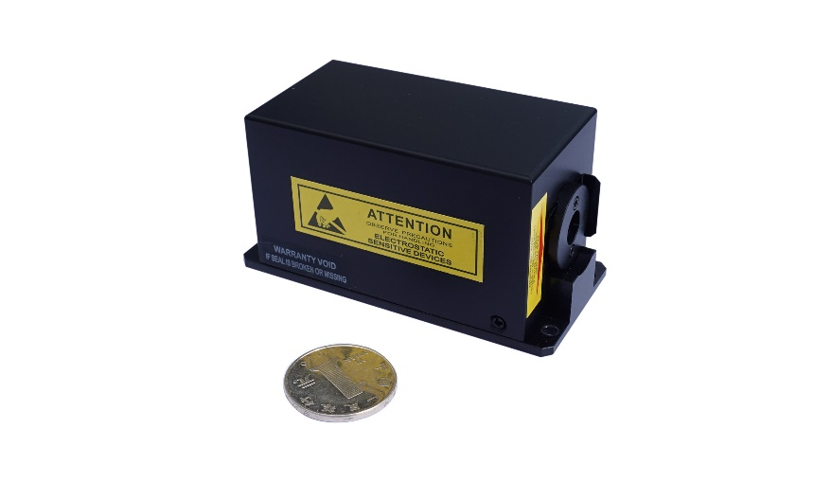



**Table 1. Optical Specification**

|  |  |  |  |  |
| --- | --- | --- | --- | --- |
| SPECIFICATIONS | W405 | W488 | W505 | W515 |
| Wavelength (nm)* | 405±5 | 488±5 | 505±5 | 515±5 |
| Output Power (mW)** | 20,50,80, 100,150,200,250 | 20,50,80, 100,150,200 | 20,50,80 | 20,50,80, 100,150 |
| RMS Noise (20Hz to 20 MHz) (%) | ≤0.1 | ≤0.1 | ≤0.1 | ≤0.1 |
| Peak to Peak Noise (20Hz to 20kHz) (%) | <0.5 | <0.5 | <0.5 | <0.5 |
| Long-Term Power Stability (8hrs, ±3ºC) (%) | <2 | <2 | <2 | <2 |
| Spatial Mode (TEM00) M2 | <1.3 | <1.3 | <1.3 | <1.3 |
| Beam Symmetry | ≥90% | ≥90% | ≥90% | ≥90% |
| Beam Diameter at 1/e2 (mm) @150mm | 0.85±0.1 | 0.7±0.1 | 0.7±0.1 | 0.7±0.1 |
| Beam Divergence Angle (mrad, full angle) | <1.2 | <1.2 | <1.4 | <1.4 |
| Pointing Stability (µrad)  (over 2 hours after warm up and ±3°C) | <30 | <30 | <30 | <30 |
| Pointing Stability Over Temperature (µrad/°C) | <5 | <5 | <5 | <5 |
| Warm-Up Time (from cold start) (minutes) | <5 | <5 | <5 | <5 |
| Polarization Ratio (dB) | >100:1 | >100:1 | >100:1 | >100:1 |
|  | Vertical ±5º | Vertical ±5º | Vertical ±5º | Vertical ±5º |

|  |  |  |  |  |
| --- | --- | --- | --- | --- |
| SPECIFICATIONS | W532 | W561 | W638 | W785 |
| Wavelength (nm)* | 532±5 | 561±1 | 638±5 | 785±5 |
| Output Power (mW)** | 20,50,80,100 | 20,45 | 20,50,80, 100,150 | 20,50,80,100 |
| RMS Noise (20Hz to 20 MHz) (%) | ≤0.25 | ≤0.25 | ≤0.1 | ≤0.1 |
| Peak to Peak Noise (20Hz to 20kHz) (%) | <1 | <1 | <0.5 | <0.5 |
| Long-Term Power Stability (8hrs, ±3ºC) (%) | <2 | <2 | <2 | <2 |
| Spatial Mode (TEM00) M2 | ≤1.1 | <1.3 | <1.3 | <1.3 |
| Beam Symmetry | ≥90% | ≥90% | ≥90% | ≥90% |
| Beam Diameter at 1/e2 (mm) @150mm | 0.7±0.1 | 0.7±0.1 | 0.8±0.1 | 0.75±0.1 |
| Beam Divergence Angle (mrad, full angle) | <1.2 | <1.5 | <1.6 | <1.8 |
| Pointing Stability (µrad)  (over 2 hours after warmup and ±3°C) | <30 | <30 | <30 | <30 |
| Pointing Stability Over Temperature (µrad/°C) | <5 | <5 | <5 | <5 |
| Warm-Up Time (from cold start) (minutes) | <5 | <5 | <5 | <5 |
| Polarization Ratio (dB) | >100:1 | >100:1 | >100:1 | >100:1 |
|  | Vertical ±5º | Vertical ±5º | Vertical ±5º | Vertical ±5º |

*Other wavelengths are available

**Output power is variable in CW mode from 10% to 100% of rated power. Specifications are valid for 100% power.

**Table 2. Mechanical and Environmental Specification**

|  |  |
| --- | --- |
| Static Alignment Tolerances | All Wavelengths |
| Beam Position from Reference (mm) | ±0.5 |
| Beam Angle (mrad) | ±2.5 |
| Beam Waist Position from Exit Window (mm) | ±200 |
| Dimensions (L x W x H) (mm)* | 86x40x44 |
| Power Consumption (W) | ≤12 |
| Laser Head Baseplate Temperature (Max. ºC) | 40 |
| Heat Dissipation of Laser Head (W) | ≤12 |
| Operating Temperature (ºC) | 10 to 40 |
| Storage Temperature (ºC) | -20 to 60 |
| Humidity (%) (Non-condensing) | 10 to 90 |
| Shock (11ms duration) (Operating) (g) | 1 |
| Shock (11ms duration) (Non-operating) (g) | 30 |
| Vibration (5Hz – 500Hz) (Operating) (g) | 0.3 |
| Vibration (5Hz – 500Hz) (Non-operating) (g) | 3 |
| Laser Safety Classification | 3b |

Note: * 561nm: 100x43.2x40mm

**Table 3:** Electrical Specifications

|  |  |  |
| --- | --- | --- |
| DB 9 Connector PIN Assignment | Digital Interface | Analog Interface |
| 1* | LD_5V or 9V or 12V | LD_5V or 9V or 12V |
| 2 | Rx for RS232 | NC |
| 3 | TEC_5V | TEC_5V |
| 4 | Tx for RS232 | NC |
| 5 | TEC_GND | TEC_GND |
| 6 | NC | ADJ |
| 7 | NC | Enable |
| 8 | GND for RS232 | NC |
| 9 | LD_GND | LD_GND |

*405/488/505/515nm LD driving voltage: 9V or 12V ;532/561/638/785nm LD driving voltage: 5V

**MECHANICAL SPECIFICATIONS**

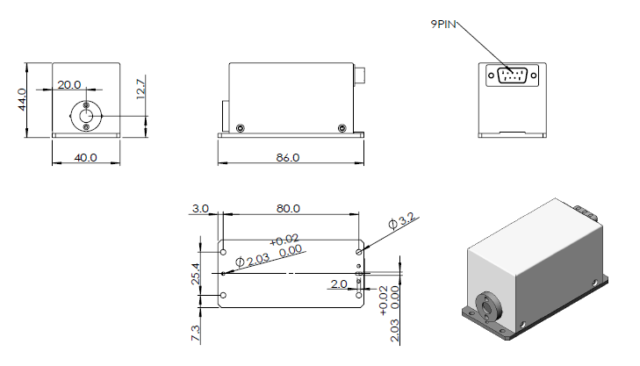

**Order Code**

WhisperlT®

Package type (e.g. W)

Wavelength (e.g. 488nm = 488)

Output Power (e.g. 10mW = 10)

Delivery (e.g. Free Space = FS, Fiber Coupled = FC)

Assigned Code (e.g. 000)

Example: W488-10FS-000

